**21.2.1**

Dear Shen,

How's it going? Things are good in China, but guess what? We want to visit you in America. Can we buy tickets to come see you next month? Talk soon

Lost of love,

Mom and Dad

They want to visit me. Next month is in three weeks

Dear Mom and Dad.

Thing are good. I'm happy you want to visit. I can take you to many fun places when you are here. Where do you want to stay?

Lost of love,

Shen

An email from Marti

Dear Shen,

I have a big gig for you.

A gig is a job. The job is teaching at a school. Speak soon.

Marti

Yes. A real actiong job. Benny Benny. I have good news

Who does Shen get his first email from?

-> His parents

Why does Shen say, "Next month is in three weeks"?

-> Three weeks is very soon

Why does Marti email Shen?

-> Marti has a job for Shen

Why does Shen yell for Benny?

-> He wants to tell Benny he has a job

My dear friend Mark,

How’s it going in your new job?

Things are good with my job.

Guess what ? I’m coming to visit ! I’m coming next month.

Can you have lunch?

See you soon.

Lots of love, Haley

**Conversation**

I'm writing an email to my friend Jane, How do I start, Lisa?

You start, "Dear Jane",

What do I out next. I want to know how she is?

You write "How's it going?"

Thanks, Now, How can I say that I'm fine and everything is well with me?

You write: "Things are good with me"

Okay, Now how do I say that I have a new job?

You can say, "Guess what? I got a new job!"

Oh, yeah, This one more thing. What do I write just befor I sign my name?

You write, "Lots of love, Dave"

**Excercise**

1. Dear Mary,

Thank you for helping me yesterday

Tim

2.Hi Kristina! How are you?

Okay, but I'm tired today

3. How's it going

Things are good

4. It is good talk to you

Thanks, Sami. Bye!

See you soon

5. Guess what?

What?

we want to visit you in France!

6. Dear Stan,

How're things?

Guess what? You sister and John want to get married!

Talk soon

Lots of love, Mom

7. How do I finish the email?

-> Lots of love, Shen

8. Dear Ryan,

I have something to tell you

Let's speak soon

Lesley

**21.2.2**

**Whose food is that?**

**It’s my food**

How are food? Why are the name Mr & Mrs Brown on it. You aren't Mr & Ms Brown

Oh yeah. They're food. It was they food

Where is it from?

LiLi

Hi Shen

What are you doing in our apartment?

A team video games

Do you play video game?

I love video game

She's good at them

I don't want to deliver food my all live, I want to design and make video games

That's cool. Why is there food in our apartment?

Well, I was in it building at Mr & Mrs Brown apartment

No isn't there in the apartment. Weird! All well

Hi LiLi. **Why are you in our hallway?**

I'm here to deliver food to Mr & Mrs Brown. But they're not at home

**I can take there food**

Ok

Hey. Do you love video games?

Yes. I have a new game in my bag right now

Do you want to play video game with me

Yes, please

**That's why I’m in your apartment**

Hey LiLi. Where start in game

**It’s in a case**

Oh, Do you want to play?

Yes.

Hey Shen, what do you want to tell me?

Oh yeah. Marti have an acting job for me

That's great Shen

That cool. What the job?

I'm a teacher

A teacher that's good role

I think so

Speaking a teacher. Benny say you in an acting class

Yes, I'm

Do you like it

That's nice, but the classes are 9 on weekend

I have to work o next weekend

Do you work everyday?

Yes, I do. It's because my parents store

OK, Do you want to talk or do you want to play video game

Do you thing you can bit me?

I can bit you

No, you can't

I need one more choose

Where does Li Li want to work?

-> At a video game company

Benny is eating the food because Mr.and Mrs. Brown aren’t home

Why is Li Li in Shen’s apartment?

-> To play video games

What does Shen tell Benny?

-> That he has a new job

**Practice**

I am looking for my car keys

My parents want to paint their house

Can I wear your coat?

Kristy wants her book back by tomorrow

Come to our house next Friday

Whose picture is this?

He put the cell phone in its case

Brian rides his bicycle to work

Skill practice

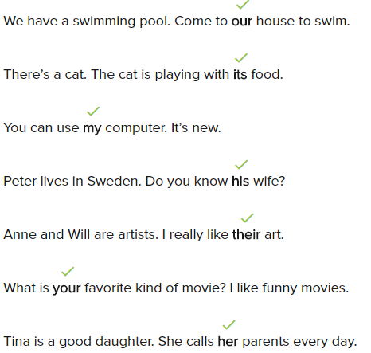

**Conversation**

Can you tell me about your family?

Yes. There are five people in my family

Your father work at the restaurant . Whose restaurant is it?

It’s his restaurant

How does your father go to work every day?

He drives his car to work every day

Does you mother like being a teacher?

Yes, She loves a students!

Your big sister much have lots of certificate. Does she study a lots?

Yes, she study for her tests every day

She study hard. What are your sister names?

They’re name Jessica and Amy

Where do you do with your family on the weekend?

We go to the park

**Excercise**

This is my new T-shirt. It was five dollars.

That woman loves red. Her car is red.

Joan: Hi. I’m new here . My name is Joan.

Karen: Hi Joan, I’m new also!This is our new school!.

Today is Sharon’s first day of work. She is looking for her desk.

Where are your books?  
They’re on the table.

Whose coffee is that?

-->It’s Joe’s coffee.

Nancy and Ken go to university. They have a big sister. Their big sister goes to medical school.

Which one is your friend?

The girl who is talking on her phone.

**Read for Meaning**

Why does Sanam send Jan a text message?

-> To tell her news

Ed and Sanam can go to San Franciso

Why can they go to San Francisco?

-> For a work trip

Jan's sister is going to Europe for a month

Where does Jan say Sanam can stay?

-> At her home

Sanam and Ed plan to be there for five days.

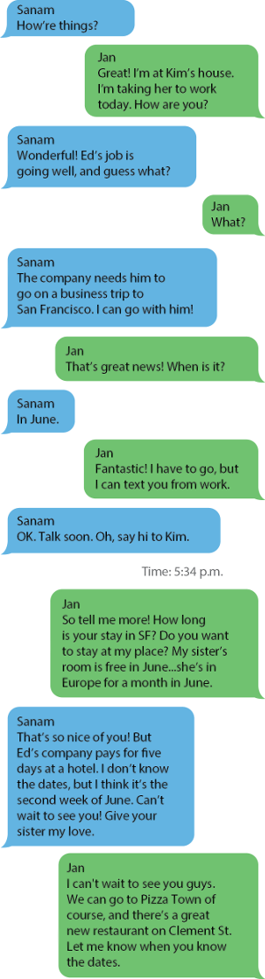

**Practice**

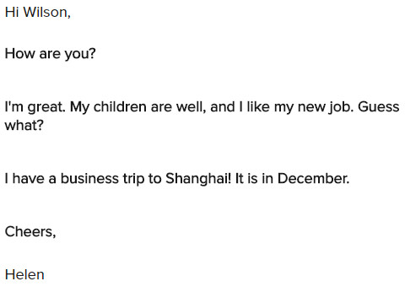

I stay at Eric’s house.

My sister’s room is free.

I’m sorry for missing Lisa’s birthday.

I’m going to Shane’s school.

These are my teacher’s books.

Whose bag is that?

**Skill Practice**

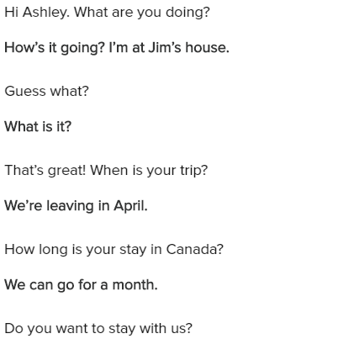

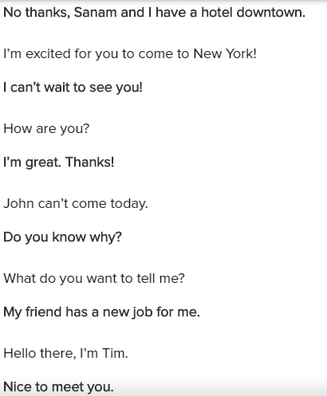

**Exercise**

1.Hi Ishmael, How are you?

2.Who has Ed's book?

-> I have it

3.I have to go now.

Cheers, Diego

4.Does Katie live with Jamie?

-> No, Katie does not live in Jamie's house.

5.John's book is in Tom's desk

6.Hi Harry,

Guess what? I have a trip to Santiago next month!

7.Hi Jenny,

How are you? How's New York?

Guess what? I am in New York next week

Can't wait to see you!

Lots of love, Anna

My brother's room is free tonights.

**Lesson Exercises**

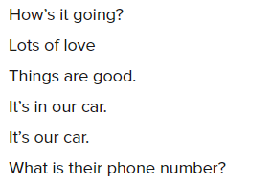

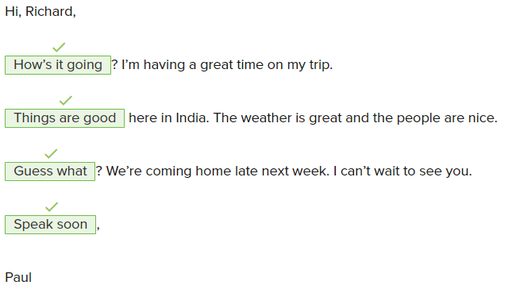

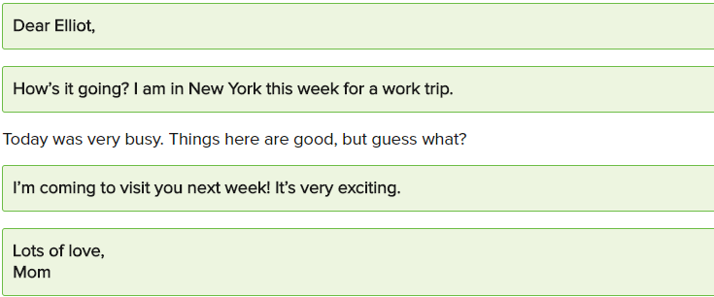

Those are their bags and notebooks.

There’s a new house on our street. Its rooms are nice, but small.

We know Bill is here at the office because his coat is in the closet.

Sue is having a great party for her mother’s birthday.

Do you know our teacher’s name?

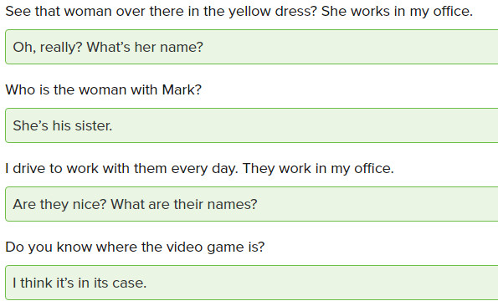

1/10

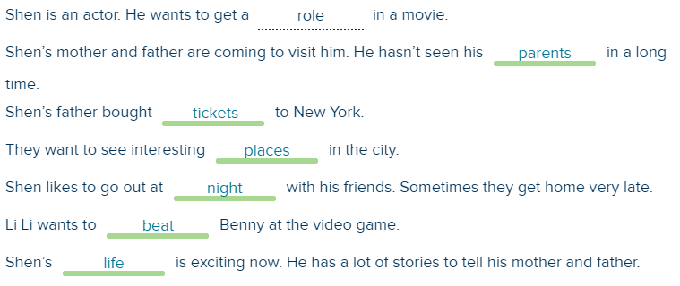

2/10

Shen is a student at the school.

=> False

The job is to teach kids at the school.

=> True

Li Li designs games.

=> False

Li Li wants a different job.

=> True

Shen is going to act like a teacher in a play, a movie, or a television show.

=> True

Shen is teaching in an acting class.

=> False

3/10

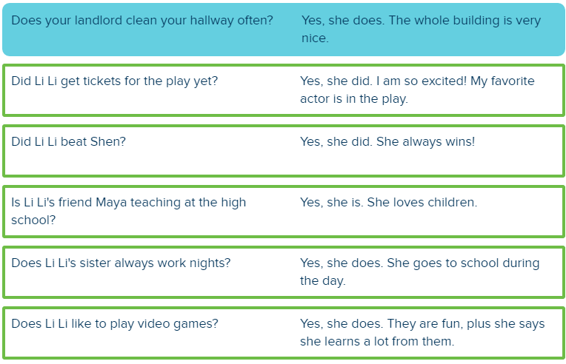

4/10

Dear Tania,

How are you? I am very busy with school and work.

Guess what?. I am visiting my parents in July. I hope I can see you then.

Love, Li Li

Dear Mom,

Hi! How's it going? Everything is OK here, but I have a cold.

I am going the doctor's office today.

I will write back tomorrow and tell you what she said.

Love, Shen

Dear Yoko:

It was great to see you yesterday. Lina and I are going to the concert in the park Friday.

Can you meet us?

Lots of love,

Benny

Dear Li Li,

How are you? Are you working now? I started working as a waitress at Town Café.

I work Mondays and Thursdays from 4 until closing. Maybe you can come see me next week.

The food is great.

See you,

Karina

Dear Shen,

Did you move to your new apartment? I hope you like it. I am going to move in August.

Maybe I can find an apartment near you.

Cheers,

Gloria

Dear Dad,

I hope you and mom are doing well. I love my job at The Company Company,

but I don’t like being so far away. I don’t know when I am going to visit. I am so busy!

I promise to call every Sunday, and I will text or email every day.

Talk soon,

Khae

5/10

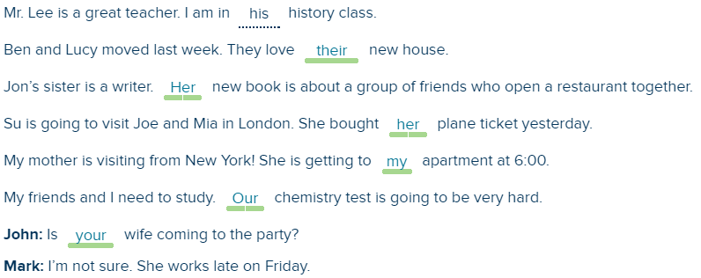

6/10

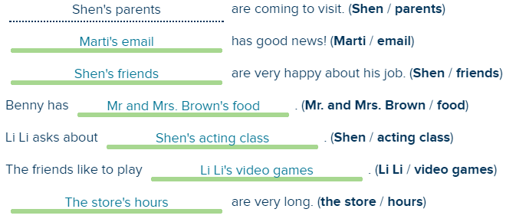

7/10

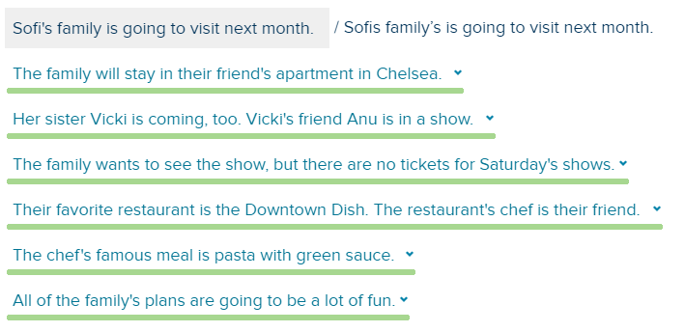

8/10

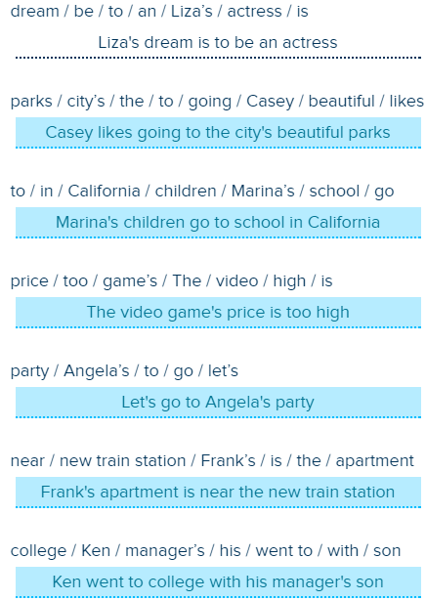

9/10

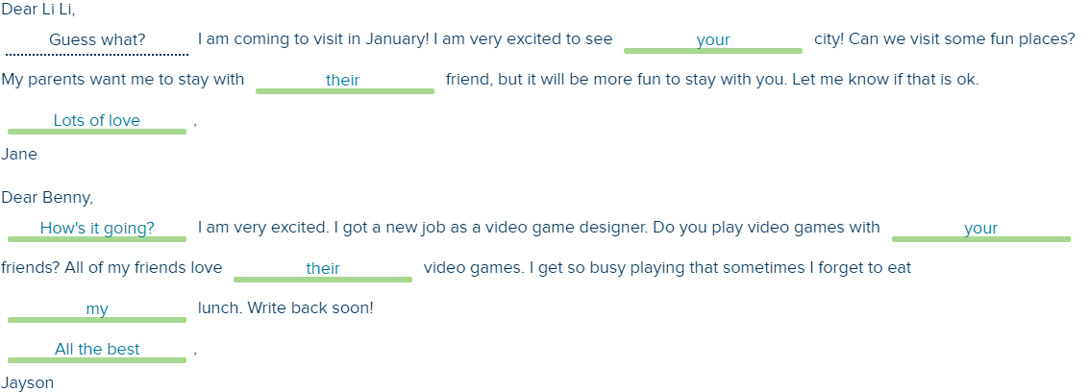

10/10

Dear Mom and Dad:

I am so excited about your visit! What time is your flight? You are going to like our apartment. It’s in a great part of the city.

Here are some things to do on your first day. First, I want to eat breakfast at Tom’s Restaurant. It looks like the diner on “Seinfeld!" Then I want to walk over the Brooklyn Bridge.Then I want to eat dim sum in Chinatown. After that, I want to go to a Broadway show.

What do you want to do after that?

Lots of love,

Julie